Kartikee Pawar

kartikee@thegamificationcompany.com

Abstract

API creation for the M2OST Integration

coroebus

## Tables of Figures

Contents

Business Requirement 3

[API 1 3](#_API_1_(Single)

[api 2 21](#_API_2_(ID)

# Business Requirement

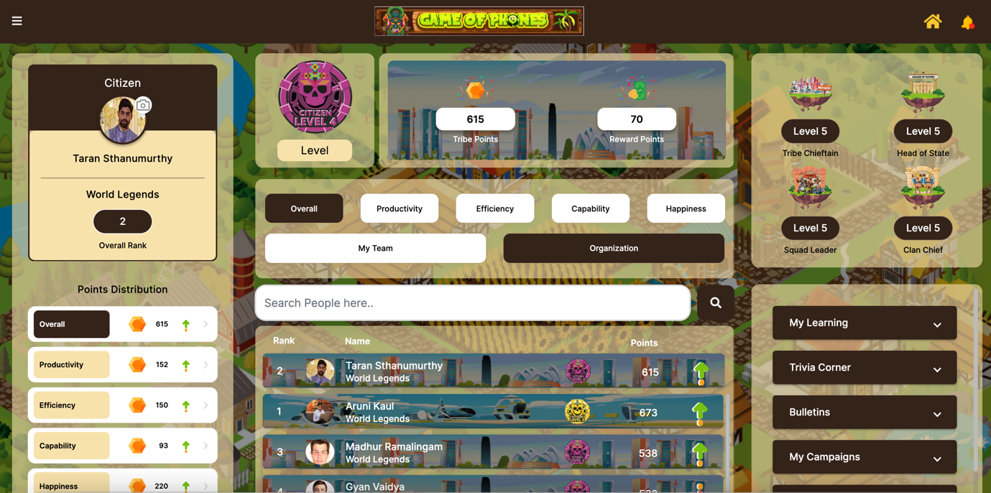

In the current system we provide a static List to the user according to the role. New APIs need to be created for the single sign on(SSO) and redirection URL. Once the user clicks on the my learning the API will be fired and the user will be created in M2OST. Once the user is created Id based list with redirection URL(Response) should be passed through the API.

# API 1 (Single sign on API)

Single sign on API needs to be created in which the information we will be passing is the

* Employee Id
* Employee Email
* Employee Name
* Game Name
* Category

# API 2 (ID based List )

Once the user is created role id based list along with the redirection URL should be given in the API as a response.

